Annex for LCQ 8
From September 28, 2001, the carriage of knife, knife-like object or bladed item of any length or description into the aircraft cabin and the Enhanced Security Restricted Area (ESRA) of the Hong Kong International Airport is banned. This is to tighten up, for general enhancement of security, the previous list of restricted articles under which knives with blades less than 76 mm in length are allowed. If passengers do wish to carry these items, they may put them into their check-in baggage. From the same day, the sale of these items at all airport shops in ESRA is also banned. The following items, however, are permitted for carriage into the aircraft cabin / ESRA.
- Nail clippers (with nail file) - length of nail clippers (not including nail file) is less than 6 cm long;
- Round-ended nail files and
- Round-ended scissors with blade less than 5 cm long.

Articles Restricted to be Carried into Aircraft Cabin
Restricted Articles
Examples of a restricted article would include:
(a) Firearms including shotguns, air guns, humane killers, bolt guns, flare pistols and starting pistols, ammunition, replica or imitation firearms, cross bows.
(b) Explosive material, including military, commercial or home-made explosive, explosive devices, detonators, smoke cartridges, grenades, mines and other explosive military ordinance, replica or imitation explosive material or devices.
(c) Pointed or bladed items made or adapted to cause injury, flick knives, gravity catch knives, stilettos, daggers, kukris, other knives both real or ceremonial with blades of any length or description, including sheath knives, kirpans and skeandhus, open razors, scalpels, ice picks, swords, sword sticks, umbrellas containing sword blades, harpoons, spears or arrows.
(d) Items containing incapacitating substances, including tear gas, mace and phosphorous acids.
(e) Highly inflammable substances (e.g. petrol, lighter fuel, etc.)
(f) Gas containers and aerosols with a capacity of more than 500 millilitres.
(g) Knuckle-dusters, clubs, coshes, rice flails.
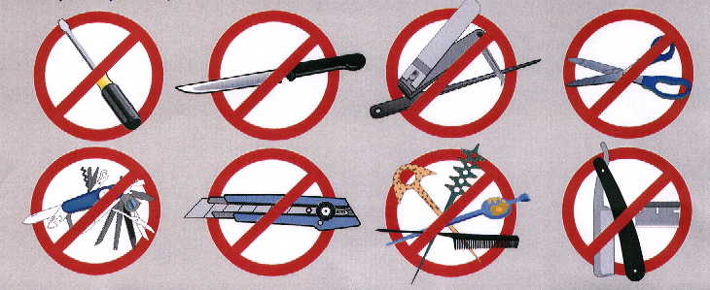

Definition of pointed item and bladed item
 | Allowable items for carriage | Not allowable items for carriage
 | 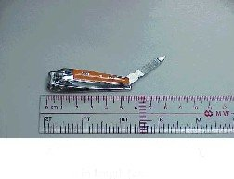  Below 6 cm in length (excluding nail file) | 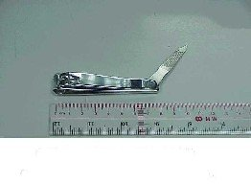  Over 6 cm in length (excluding nail file)
 | 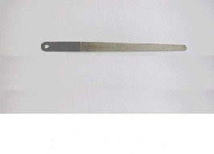  Round-ended nail file | 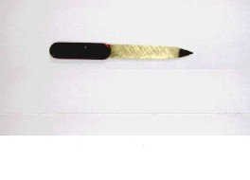  Pointed nail file
 | 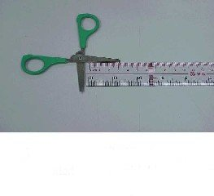  Round-ended scissors with  blade below 5 cm in length | 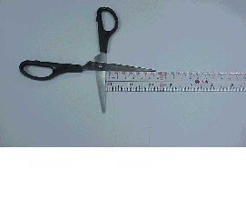  Pointed scissors or scissors with  blade over 5 cm in length

